# Data Audit Dashboard KPIs

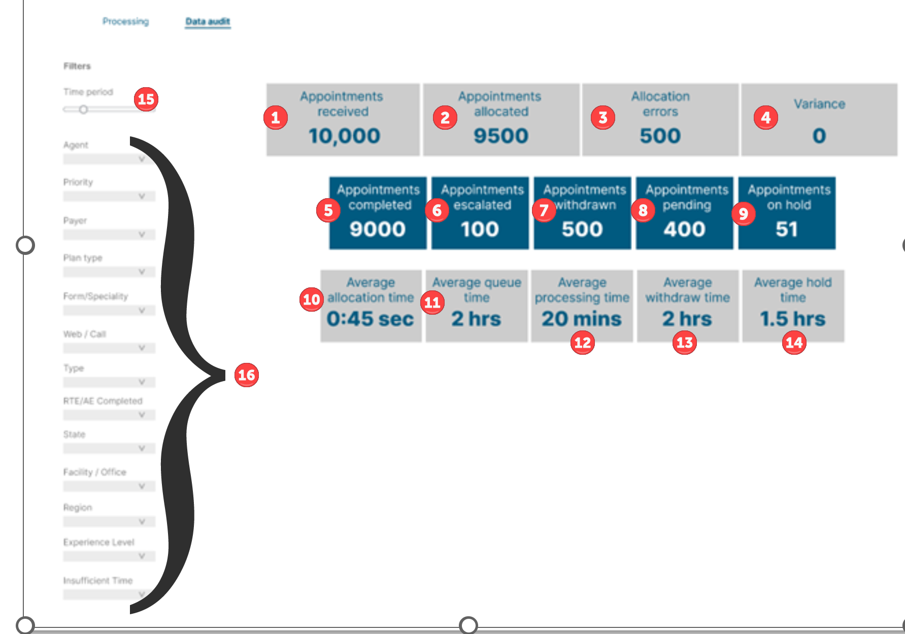

| **#** | **Metric** | **Description** | **Mapping/Calculation** |
| --- | --- | --- | --- |
| 1 | Appointments Received | Number of appointments received to the application | * ~~Table: AppAppointment~~ * ~~Calculation: COUNT of all appointments~~ * Table: [IMPORT].[File_Log] * Calculation: SUM (ROW_COUNT) for each file received within the date filter selected. * Display as number * *\*May be filtered based on filters used.* |
| 2 | Appointments Allocated | Number of appointments allocated to queues | * ~~Table: AppAppointment~~ * ~~Calculation: COUNT of all appointments with Appointment Status = In Progress or On Hold~~ * Table: [IMPORT].[File_Log] * Calculation: SUM (ImportedRowsCount) for each file received within the date filter selected. * Display as number * *\*May be filtered based on filters used.* |
| 3 | Allocation Errors | Number of appointments that were unable to be allocated | * Table: [IMPORT].[LogInfo] * The ImportFileID in [IMPORT].[LogInfo] is referring to the File_id in [IMPORT].[File_Log] so using this relation you can link the 2 tables * Calculation: COUNT of records in [IMPORT].[LogInfo] for the file(s). * *\*May be filtered based on filters used.* |
| 4 | Variance | Number of appointments that were not allocated nor had errors | * Calculation: Appointments Received (-) Appointments Allocated (-) Allocation Errors |
| 5 | Appointments Completed | Number of appointments successfully verified by an agent | * Table: App Appointment * Calculation: COUNT of all appointments with Appointment Status = Completed * Display as number * *\*May be filtered based on filters used.* |
| 6 | Appointments Escalated | Number of appointments escalated to PDS | * Table: App Appointment * Calculation: COUNT of all appointments with Appointment Status = Escalated * Display as number * *\*May be filtered based on filters used.* |
| 7 | Appointments Withdrawn | Number of appointments withdrawn by PDS prior to verification | * N/A – Future implementation – Ignore. |
| 8 | Appointments Pending | Number of appointments pending to be verified | * Table: App Appointment * Calculation: COUNT of all appointments with Appointment Status = In Progress or Not Assigned * Display as number * *\*Not applicable when either Date Range is entered.* |
| 9 | Appointments On Hold | Number of appointments currently on hold | * Table: App Appointment * Calculation: COUNT of all appointments with Appointment Status = On Hold * Display as number * *\*Not applicable when either Date Range is entered.* |
| 10 | Average Allocation Time | Time from hitting the queue to being allocated to a queue | * Table: AppAppointment   + Created_Date * Table: AppAppointmentQueue_Allocation   + Created_Date * Calculate the difference between these dates for each appointment (AllocationTime) * Calculation: SUM AllocationTimes (/) SUM of Appointments used in AllocationTime |
| 11 | Average Queue Time | Time from hitting a queue to being assigned to an agent | * Table: AppAppointmentProcessingDetails   + Created_Date * Table: AppAppointmentQueue_Allocation   + Created_Date * Calculate the difference between these dates for each appointment (QueueTime) * Calculation: SUM QueueTimes (/) SUM of Appointments used in QueueTime |
| 12 | Average Processing Time | Time being actively worked by an agent | * Table: APP.AppointmentProcessingTime * The time is calculated based on the date difference of columns StartTime and StopTime with respect to an appointment id. * Calculate the difference between these dates for each appointment (ProcessingTime) * Calculation: SUM ProcessingTime (/) SUM of Appointments used in ProcessingTime |
| 14 | Average Hold Time | Time in on hold status | * Table: APP.HoldProcessingTime * The time is calculated based on the date difference of columns StartTime and StopTime with respect to an appointment id. * Calculate the difference between these dates for each appointment (HoldTime) * Calculation: SUM HoldTime (/) SUM of Appointments used in HoldTime |
| ~~13~~ | ~~Average Withdraw Time~~ | ~~Time from hitting a queue to being withdrawn~~ | * ~~N/A – Future implementation – Ignore.~~ |

## **Filters**

| **#** | **Filter** | **Description/Mapping** |
| --- | --- | --- |
| 15 | Time Period  Received Date From  Received Date To | * Allows the user to filter by a date. User can enter a Date From and Date To range. * Use [IMPORT].[File_Log].Created_date * Applicable to KPIs 1 - 4. |
| 15 | Completion Date From  Completion Date To | * Allows the user to filter by a date. User can enter a Date From and Date To range. * Use AppAppointmentProcessingDetail.LU * Applicable to all KPIs.   **Note: Should be the date that the appointment was placed in a Completed or Escalated status.** |
| 16 | Agent | * Allows the user to select one or multiple agent names. All active agents should display. * Table: AppUser where Active = True and   Table: AppUserRole where AppUser has Role=Agent   * Table: AppAppointmentProcessingDetail maps using UserID and AppointmentID to table AppAppointment * Applicable to KPIs 5,6,7,8,9 |
| 16 | Priority | * Allows the user to select one or multiple priorities (Same Day, Next Day, Future). * Use AppAppointment.QueuePriority * Applicable to all KPIs |
| 16 | Payer | * Allows the user to select one or multiple payers. * Use AppAppointment.CarrierID and AppCarrierDetails.CarrierName * Applicable to all KPIs |
| 16 | Plan Type | * Allows the user to select one or multiple plan types (PPO, HMO). * Use AppAppointment.CarrierID and AppCarrierDetails.PlanType * Applicable to all KPIs |
| 16 | Form/Specialty | * Allows the user to select one or multiple form/specialties (GP, ORTHO, PEDO). * Use AppAppointment.Form_Specialty * Applicable to all KPIs |
| 16 | Web/Call | * Allows the user to select one or multiple web/calls (Web, Call). * Use AppAppointment.CarrierID and AppCarrierDetails.ContactType * Applicable to all KPIs |
| 16 | Type | * Allows the user to select one or multiple types (Full, Partial). * Use AppAppointment. Type_of_Check_to_Perform * Applicable to all KPIs |
| 16 | RTE/AE Completed | * Allows the user to select one or multiple RTE/AE Completes (TRUE, FALSE). * Use AppAppointment.RTE_AE_Completed * Applicable to all KPIs |
| 16 | State | * Allows the user to select one or multiple States. * Use AppAppointment.Office_ID with LookupOffice.Office_ID where LookupOffice.Active = TRUE   + LookupOffice.State * Applicable to all KPIs |
| 16 | Facility/Office | * Allows the user to select one or multiple Facility/Offices. * Use AppAppointment.Office_ID * Applicable to all KPIs |
| 16 | Region | * Allows the user to select one or multiple Regions. * Use AppAppointment.Office_ID with LookupOffice.Office_ID where LookupOffice.Active = TRUE   + LookupOffice.Region * Applicable to all KPIs |
| ~~16~~ | ~~Experience Level~~ | * ~~TBD~~ * ~~Applicable only to KPIs 5,6,7,8,9~~ |
| 16 | Insufficient Time | * Allows the user to select one or multiple Insufficient times (Yes, No) * Use AppAppointment.InsufficientTime * Applicable to all KPIs |